**Database Analysis and Design**

**Entities and Relationships:**

* **Product:** Contains details about products sold.
* **Category:** Each product belongs to a specific category.
* **Employee:** Details of supermarket staff.
* **Customer:** Information about customers.

**ER Diagram and Normalization**

* **Product:** ProductID, Name, Price, CategoryID
* **Category:** CategoryID, Name
* **Employee:** EmployeeID, Name, Position
* **Customer:** CustomerID, Name, ContactInfo

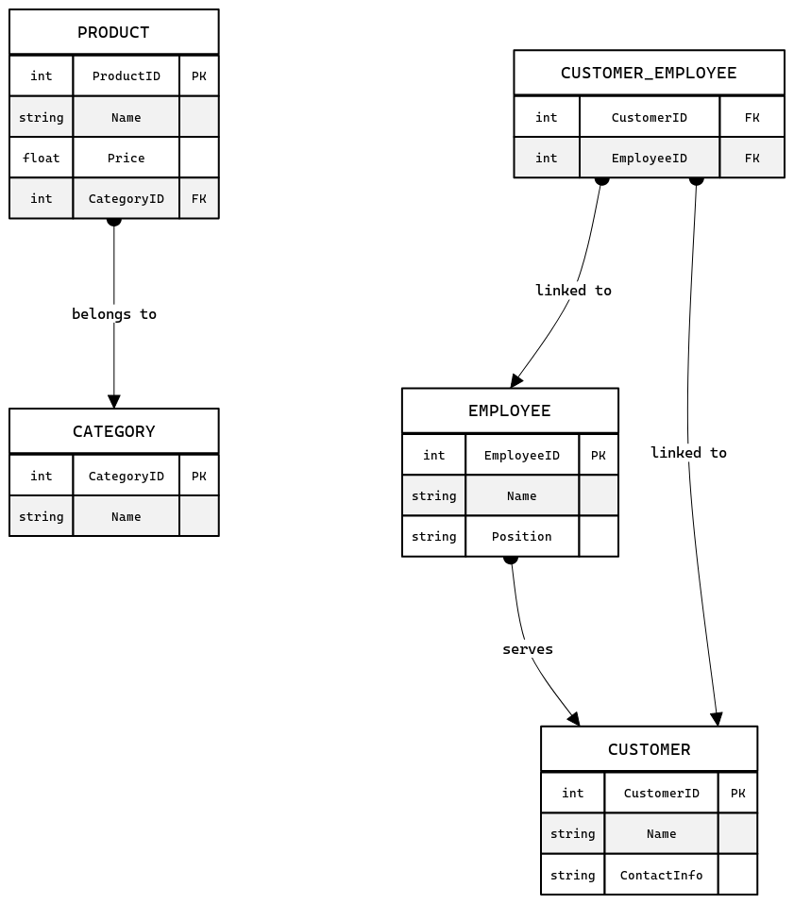

**Create tables:**

CREATE TABLE Category (

CategoryID INT PRIMARY KEY,

Name VARCHAR(255)

);

CREATE TABLE Product (

ProductID INT PRIMARY KEY,

Name VARCHAR(255),

Price DECIMAL(10,2),

CategoryID INT,

CONSTRAINT fk_Category

FOREIGN KEY (CategoryID)

REFERENCES Category(CategoryID)

);

CREATE TABLE Employee (

EmployeeID INT PRIMARY KEY,

Name VARCHAR(255),

Position VARCHAR(255)

);

CREATE TABLE Customer (

CustomerID INT PRIMARY KEY,

Name VARCHAR(255),

ContactInfo VARCHAR(255)

);

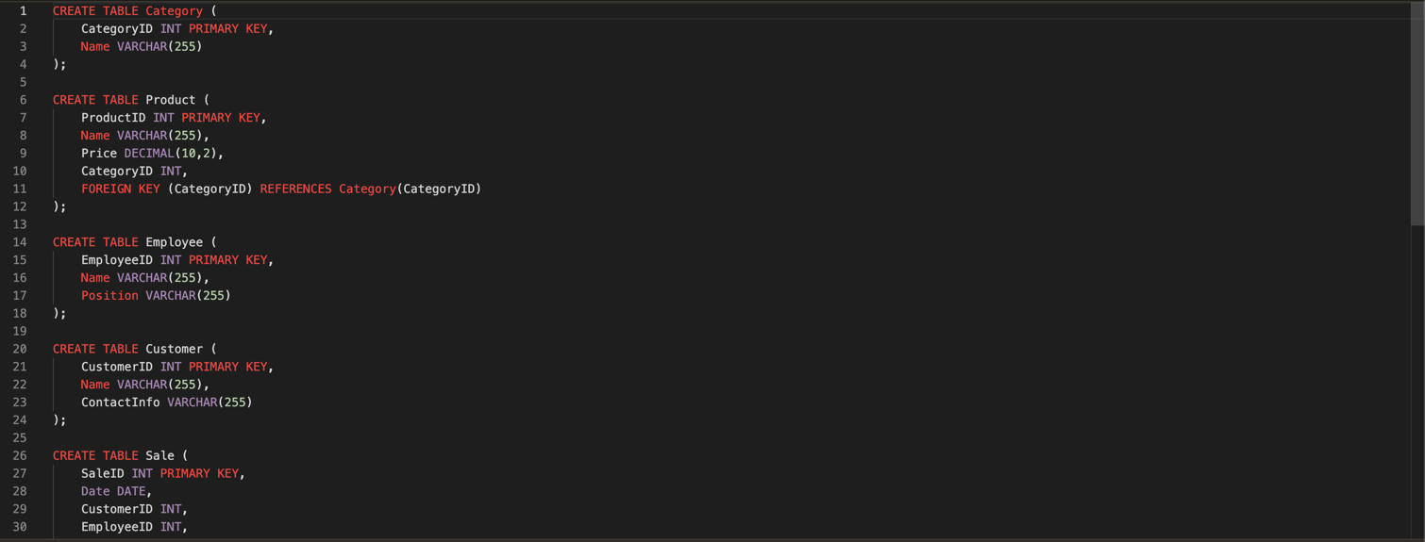

**Insert data**

**1. Category Table**

INSERT INTO Category (CategoryID, Name) VALUES (1, 'Dairy');

INSERT INTO Category (CategoryID, Name) VALUES (2, 'Beverages');

INSERT INTO Category (CategoryID, Name) VALUES (3, 'Bakery');

INSERT INTO Category (CategoryID, Name) VALUES (4, 'Fresh Produce');

**2. Product Table**

INSERT INTO Product (ProductID, Name, Price, CategoryID) VALUES (101, 'Milk', 1.99, 1);

INSERT INTO Product (ProductID, Name, Price, CategoryID) VALUES (102, 'Cheese', 4.50, 1);

INSERT INTO Product (ProductID, Name, Price, CategoryID) VALUES (201, 'Coffee', 3.99, 2);

INSERT INTO Product (ProductID, Name, Price, CategoryID) VALUES (202, 'Green Tea', 2.99, 2);

INSERT INTO Product (ProductID, Name, Price, CategoryID) VALUES (301, 'Bread', 2.50, 3);

INSERT INTO Product (ProductID, Name, Price, CategoryID) VALUES (302, 'Donuts', 5.00, 3);

INSERT INTO Product (ProductID, Name, Price, CategoryID) VALUES (401, 'Apples', 1.50, 4);

INSERT INTO Product (ProductID, Name, Price, CategoryID) VALUES (402, 'Lettuce', 0.99, 4);

**3. Employee Table**

INSERT INTO Employee (EmployeeID, Name, Position) VALUES (1, 'John Doe', 'Manager');

INSERT INTO Employee (EmployeeID, Name, Position) VALUES (2, 'Jane Smith', 'Cashier');

INSERT INTO Employee (EmployeeID, Name, Position) VALUES (3, 'Emily White', 'Stock Clerk');

INSERT INTO Employee (EmployeeID, Name, Position) VALUES (4, 'Chris Green', 'Sales Assistant');

**View reports :**

SELECT

c.Name AS Category_Name,

AVG(p.Price) AS Average_Price,

MIN(p.Price) AS Minimum_Price,

MAX(p.Price) AS Maximum_Price

FROM

Product p

JOIN

Category c ON p.CategoryID = c.CategoryID

GROUP BY

c.Name

ORDER BY

AVG(p.Price) DESC;

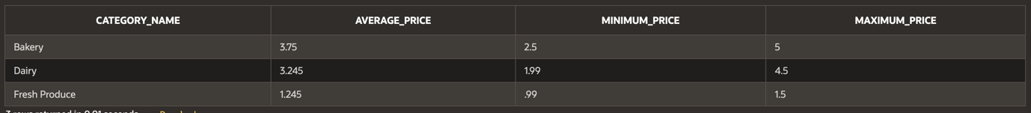

SELECT

CustomerID,

Name,

ContactInfo

FROM

Customer

ORDER BY

SELECT

ProductName,

Price

FROM

ProductCatalog

WHERE

CategoryName = 'Dairy';



**User Interface Design using Oracle apex**

